**Steps :-**

1. **Create new project > select java > java application**

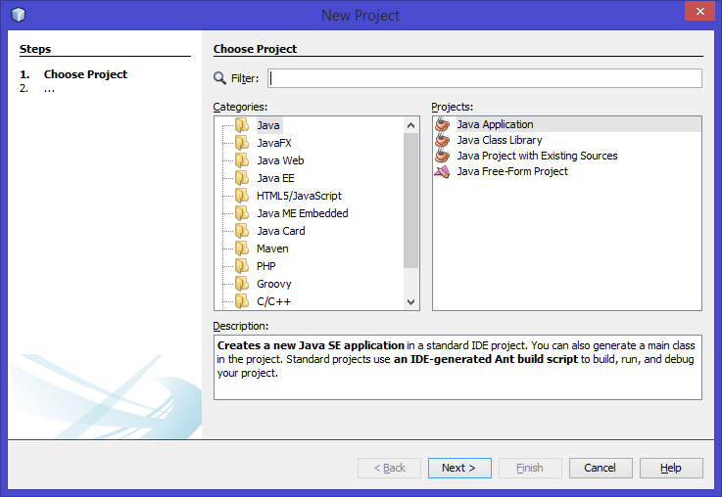

1. **Give the name of new project**

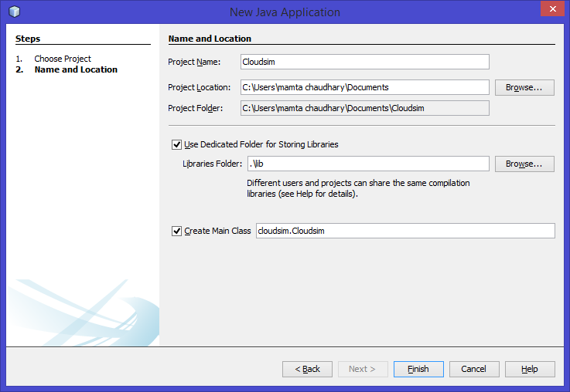

**3. Extract cloudsim source**

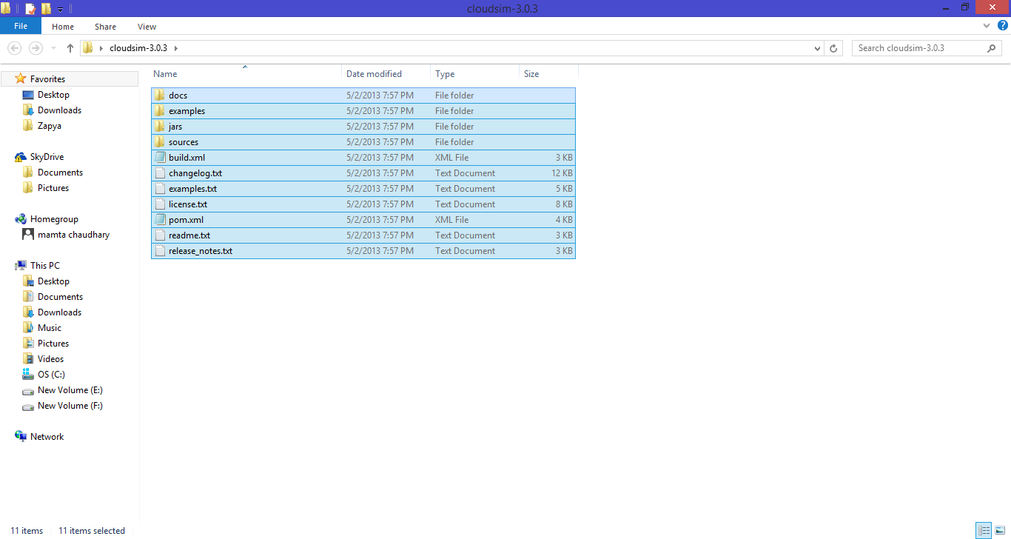

**4. Copy all files to the src folder in your project**

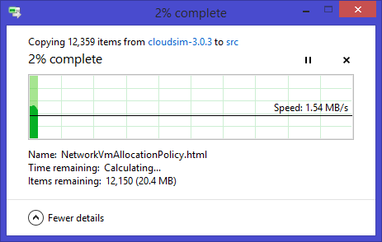

**5. Click on project properties.**

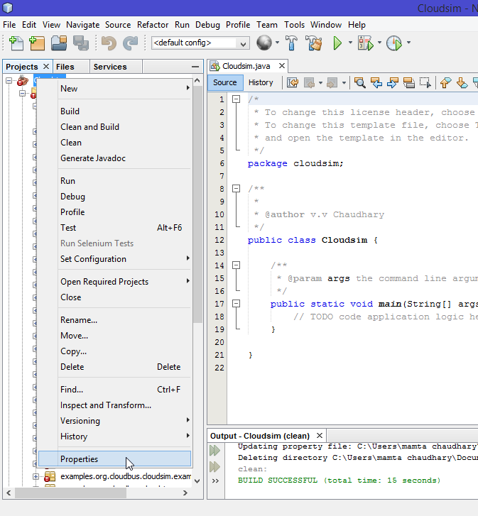

**6. Click on libraries > add jar/folder**

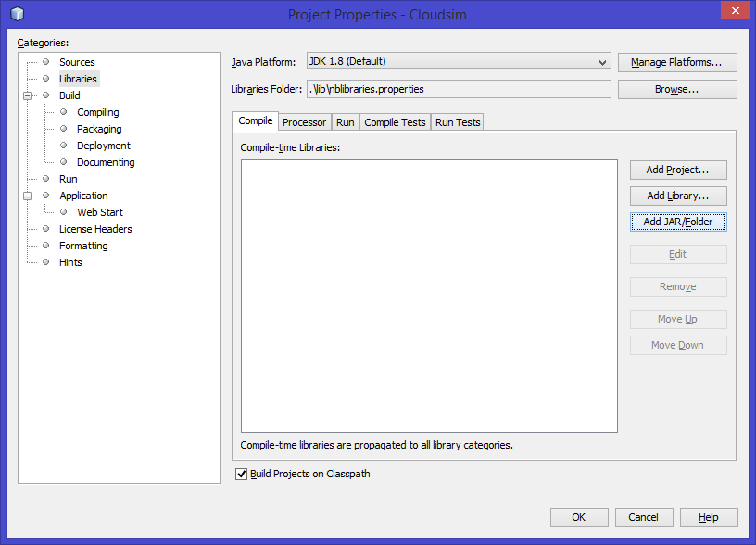

**7. Select all files from src > jar folder and click open**

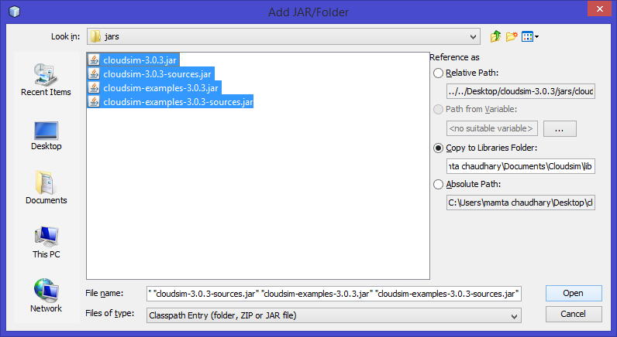

**8. Run project and select example 1 and example 2**

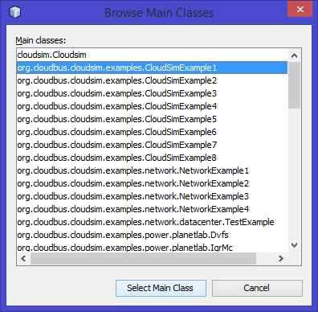

**9. Output of example 1**

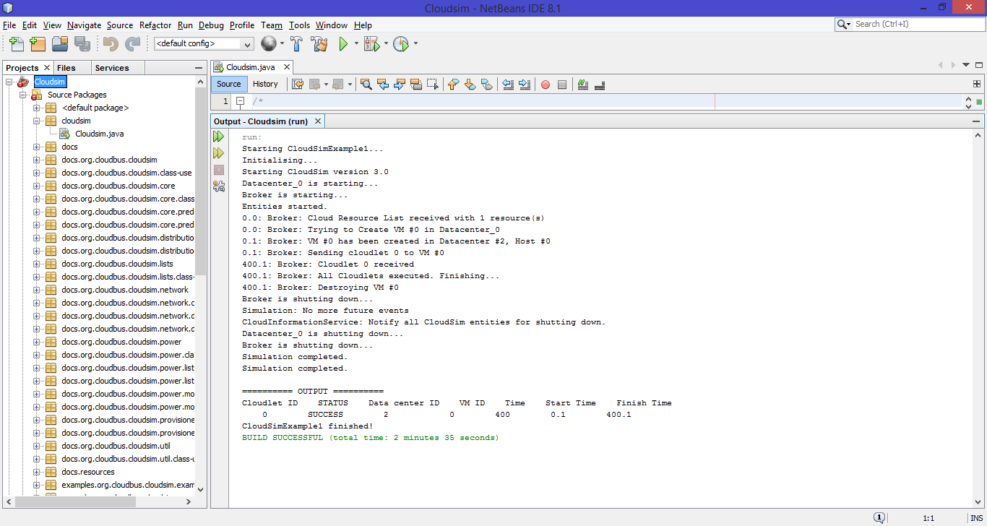

**10. Output of example 2**

